**Using a subflow as a user-defined node**

1. **Introduction :-**

* user-defined nodes can be exported as a plug-in that is installed in the development environment of the user.
* The nodes that are packaged in the plug-in are displayed in the palette in the Message Flow editor, and can be used in a message flow in the same way as a built-in node.

Packaging a subflow as a user-defined node provides all the benefits of a subflow, such as reusability and maintainability, as well as the following benefits:

* The user-defined node can be distributed to other developers as a plug-in.
* The user-defined node hides the implementation details of the subflow from developers who reuse the subflow.
* The user-defined node prevents developers who reuse the subflow from modifying it.
* The subflow is displayed in the palette in the Message Flow editor.

1. **Configurations for Using a subflow as a user-defined node**

* Creating the static library with subflow.

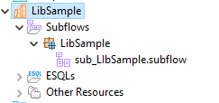

* Right click on the Library and then will see sublflow user-defined nodes click on that .Display the Set pallette category click on category.

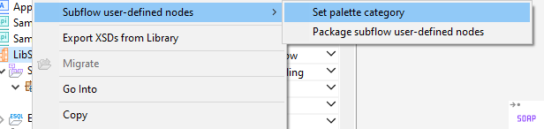

* Wee need to require for the icons for the small size and big size.Adding the icons in category area.

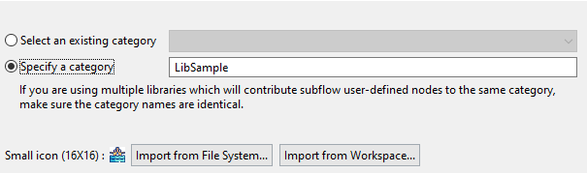

* It will automatically add and visible in the pallet.



* Creating the message flow based on the requirement In this I have to transfer the data from XML to JSON.

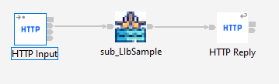

* After test in postman we will see the results.

